SERVICE: BOOKING
PROCESS: CENTURY VMS BOOKING
CENTURY VMS AUTOMATION FOR EPIC
WEB: https://www.centuryvms.com
ID: AMZ1599-0
PW: epic123456

CLOSE THE POP UP
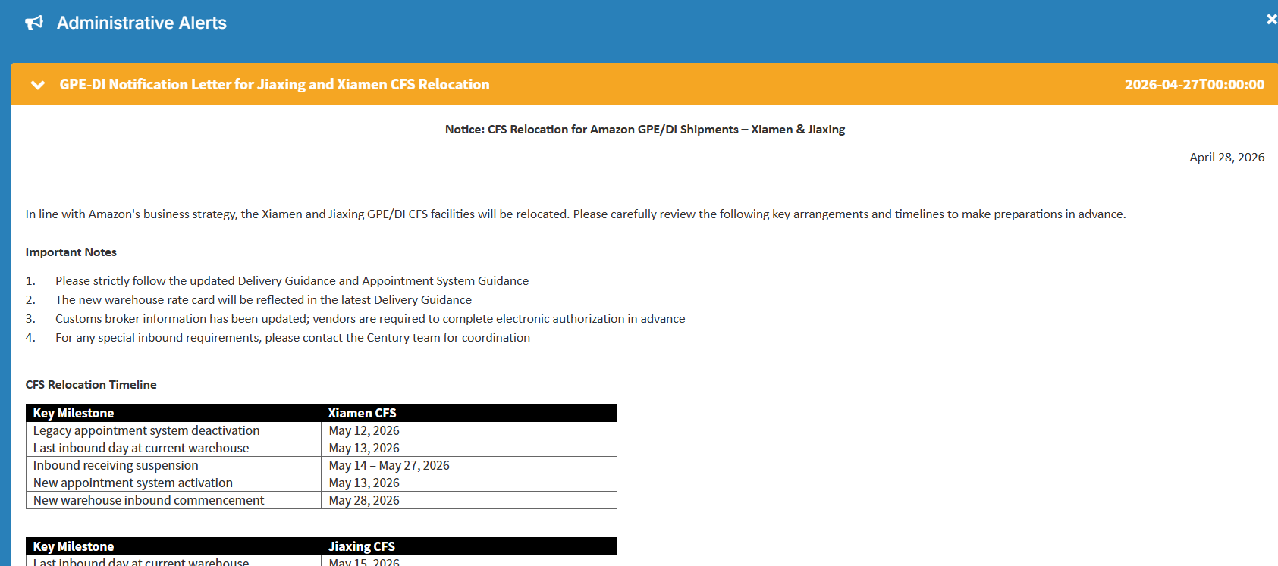

STEP:02
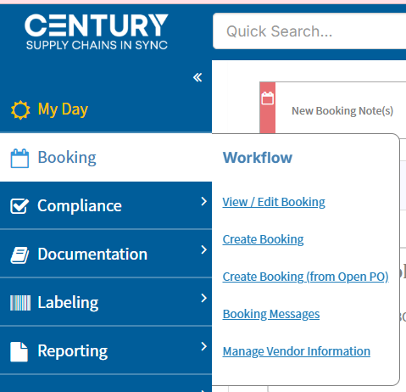

CLICK BOOKING THEN CREATE BOOKING.

STEP:03

